Lateral Movement and Persistence Report

1. Objective
The objective of this exercise was to demonstrate lateral movement using valid credentials and establish persistence on a Windows system within a controlled lab environment.

2. Lab Environment
Attacker Machine: Kali Linux
Target Machine: Windows Virtual Machine
Network: Host-only lab setup
Tools Used: Impacket (psexec.py)

3. Lateral Movement Using PsExec
Valid administrative credentials were used to authenticate to the Windows system over SMB. Impacket’s psexec tool was used to create and execute a remote service on the target machine. This allowed command execution with SYSTEM-level privileges, demonstrating lateral movement.
Command Used:
impacket-psexec pentest:Password123@192.168.56.102
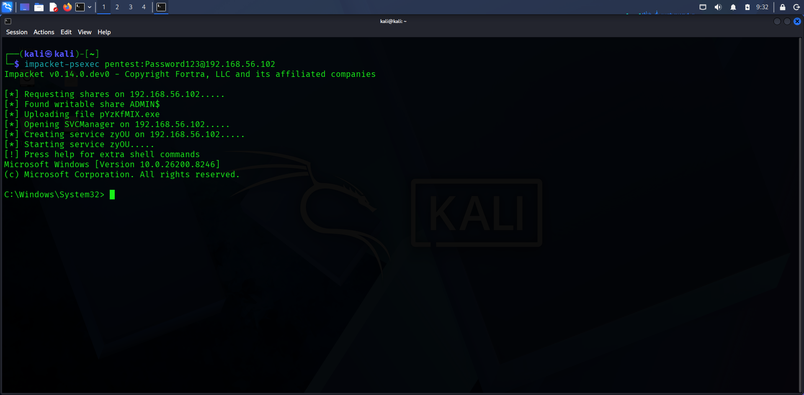

4. Verification of Access
After gaining access, the "whoami" command was executed to confirm privilege level. The output showed NT AUTHORITY\SYSTEM, confirming full administrative control over the system.

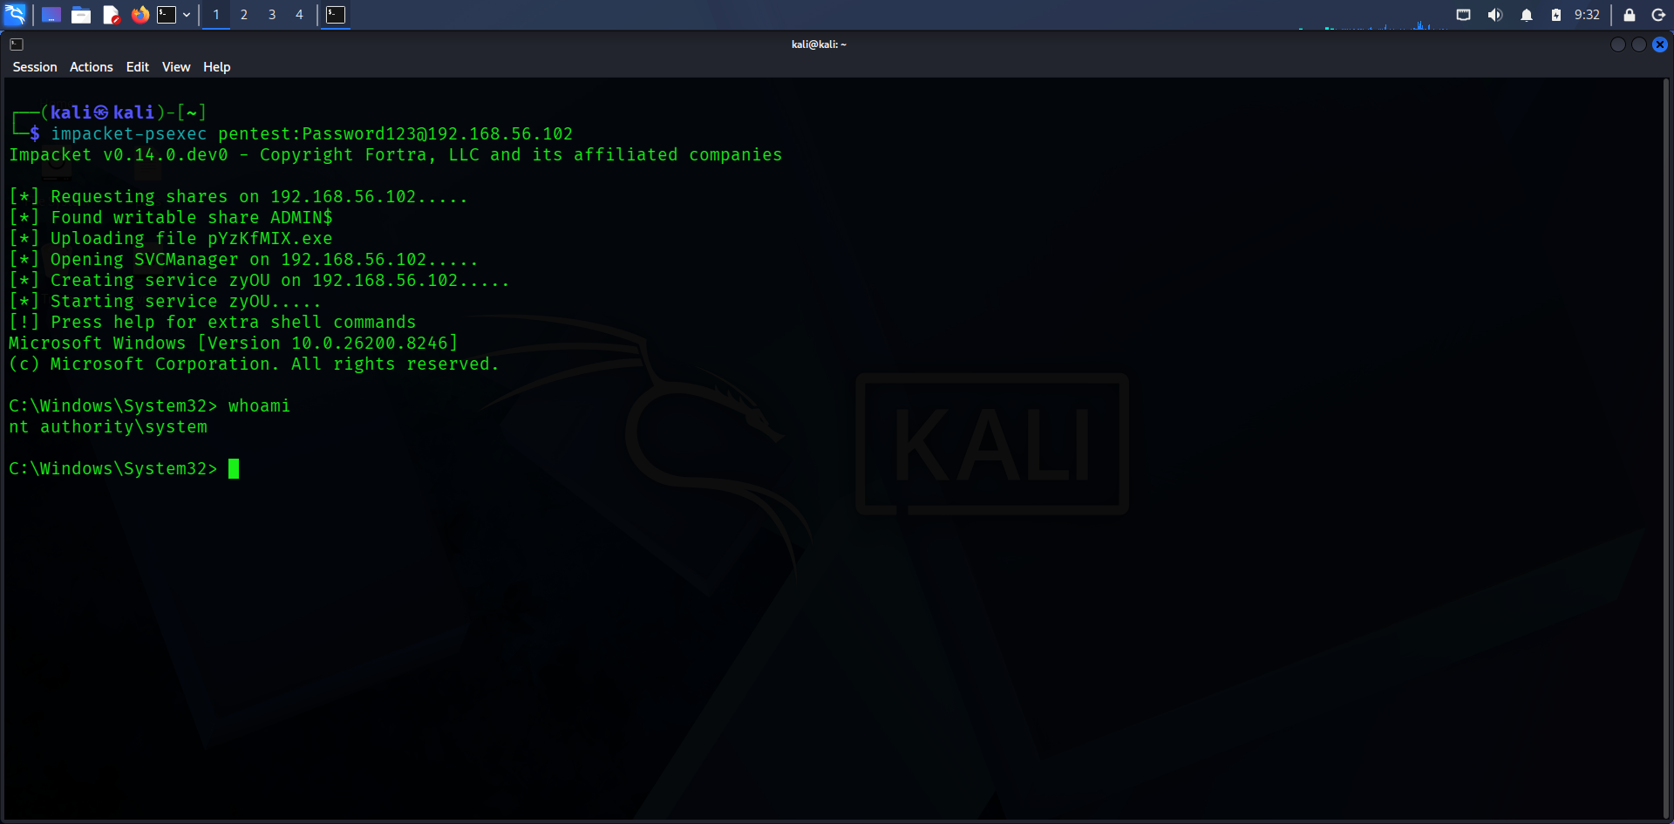

5. Persistence Mechanism
A scheduled task was created to ensure persistence. The task runs every minute and executes a command with SYSTEM privileges. This ensures continued access even if the initial session is terminated.
Command Used:
schtasks /create /sc minute /mo 1 /tn "Updater" /tr "cmd.exe /c calc.exe" /ru SYSTEM

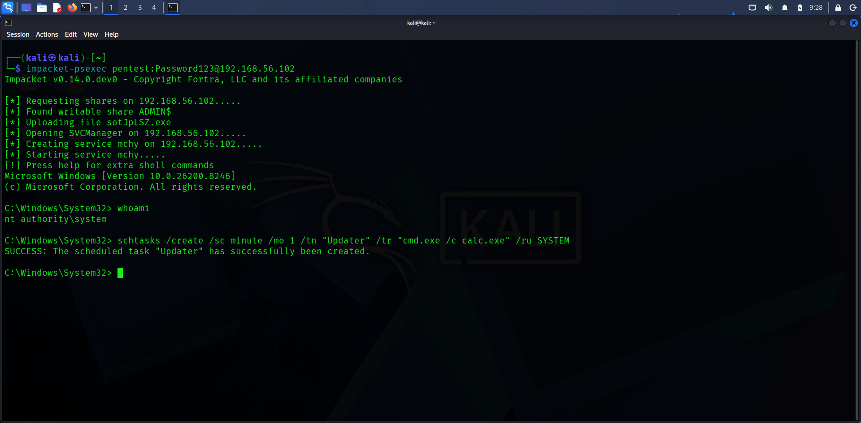

6. Impact
The system is configured to execute commands repeatedly with the highest privilege level. While a harmless command was used in this lab, such persistence techniques can allow attackers to maintain long-term access, execute malicious payloads, and regain control after disconnection or reboot.

7. Log Table
Technique | Tactic | Description | Notes
PsExec | Lateral Movement | Remote command execution via SMB | Requires admin credentials
Scheduled Task | Persistence | Recurring execution of command | Runs as SYSTEM

8. Pivot Summary
Valid credentials were used to authenticate to a Windows system via SMB. Using Impacket’s psexec, a remote service was created to execute commands, resulting in SYSTEM-level access. This demonstrated lateral movement through credential reuse and remote command execution across the network.

